Az.: […] Name: […]



Az.: […] Name: […]

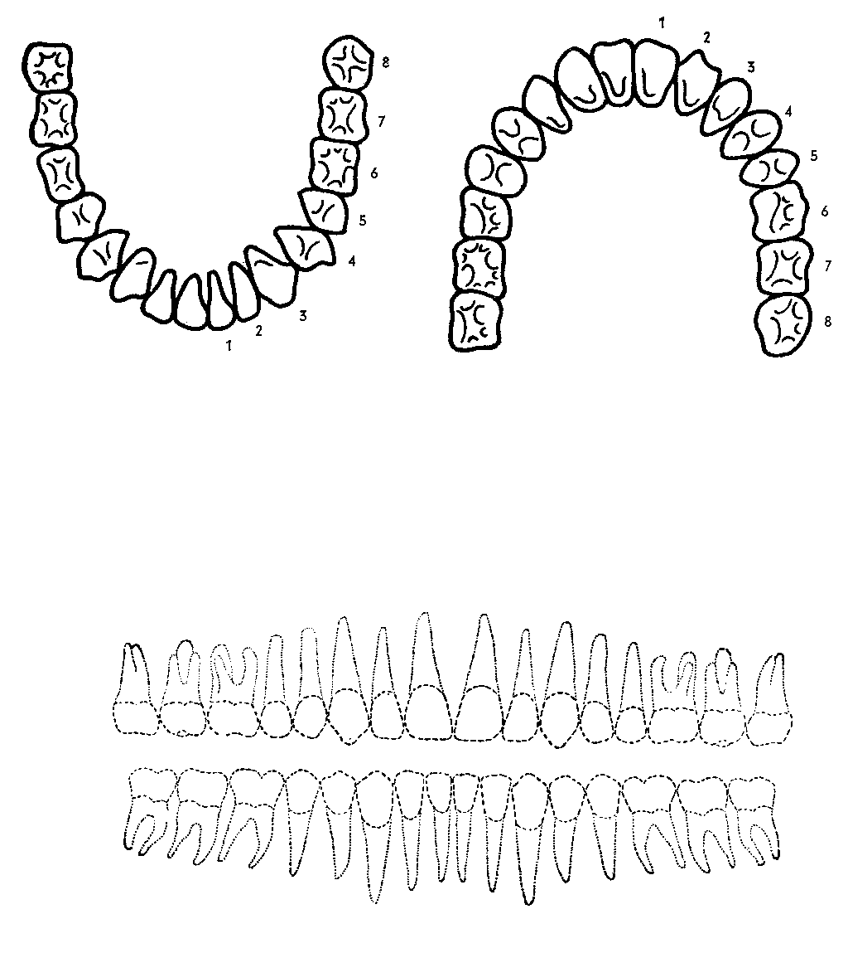

**Obere Zahnreihe**

**Untere Zahnreihe**