|  |  |  |  |  |  |  |  |  |  |  |  |  |  |
| --- | --- | --- | --- | --- | --- | --- | --- | --- | --- | --- | --- | --- | --- |
| Name, Vorname: | […] | | | | | | | |  | | | | |
| geb.: | […] | | | | | | | | | | | | |
| Unfalltag: | […] | | | | | | | | | | | | |
| **Anlage zum D-Bericht Nr.:** | | | […] | |  | | | | | | | | |
| **Ergänzungsbericht – schwere Verbrennungen -** | | | | | | | | | | | | | |
| Verbrennung | | 1 Jahr | | 1 bis 4 Jahre | | 5 bis 9 Jahre | 10 bis 14 Jahre | 15 Jahre | Erwach­sene | 2°-A*) | 2°-B*) | 3°*) | 4°*) |
| Kopf | | 19 | | 17 | | 13 | 11 | 9 | 7 | […] | […] | […] | […] |
| Hals | | 2 | | 2 | | 2 | 2 | 2 | 2 | […] | […] | […] | […] |
| Rumpf (vorn) | | 13 | | 13 | | 13 | 13 | 13 | 13 | […] | […] | […] | […] |
| Rumpf (hinten) | | 13 | | 13 | | 13 | 13 | 13 | 13 | […] | […] | […] | […] |
| Rechte Gesäßhälfte | | 2 ½ | | 2 ½ | | 2 ½ | 2 ½ | 2 ½ | 2 ½ | […] | […] | […] | […] |
| Linke Gesäßhälfte | | 2 ½ | | 2 ½ | | 2 ½ | 2 ½ | 2 ½ | 2 ½ | […] | […] | […] | […] |
| Genitalien | | 1 | | 1 | | 1 | 1 | 1 | 1 | […] | […] | […] | […] |
| Rechter Oberarm | | 4 | | 4 | | 4 | 4 | 4 | 4 | […] | […] | […] | […] |
| Linker Oberarm | | 4 | | 4 | | 4 | 4 | 4 | 4 | […] | […] | […] | […] |
| Rechter Unterarm | | 3 | | 3 | | 3 | 3 | 3 | 3 | […] | […] | […] | […] |
| Linker Unterarm | | 3 | | 3 | | 3 | 3 | 3 | 3 | […] | […] | […] | […] |
| Rechte Hand | | 2 ½ | | 2 ½ | | 2 ½ | 2 ½ | 2 ½ | 2 ½ | […] | […] | […] | […] |
| Linke Hand | | 2 ½ | | 2 ½ | | 2 ½ | 2 ½ | 2 ½ | 2 ½ | […] | […] | […] | […] |
| Rechter Oberschenkel | | 5 ½ | | 6 ½ | | 8 | 8 ½ | 9 | 9 ½ | […] | […] | […] | […] |
| Linker Oberschenkel | | 5 ½ | | 6 ½ | | 8 | 8 ½ | 9 | 9 ½ | […] | […] | […] | […] |
| Rechter Unterschenkel | | 5 | | 5 | | 5 ½ | 6 | 6 ½ | 7 | […] | […] | […] | […] |
| Linker Unterschenkel | | 5 | | 5 | | 5 ½ | 6 | 6 ½ | 7 | […] | […] | […] | […] |
| Rechter Fuß | | 3 ½ | | 3 ½ | | 3 ½ | 3 ½ | 3 ½ | 3 ½ | […] | […] | […] | […] |
| Linker Fuß | | 3 ½ | | 3 ½ | | 3 ½ | 3 ½ | 3 ½ | 3 ½ | […] | […] | […] | […] |
| Summe: | |  | |  | |  |  |  |  | […] | […] | […] | […] |
| **Gesamtverbrennung:** | | | | | | | | | | […] | | | |
|  | | | | | | | | | | *) Ausmaß und Schweregrad der Verbrennungen in entsprechende Spalte eintragen. | | | |

# ABSI-Score

|  |  |  |  |  |  |  |
| --- | --- | --- | --- | --- | --- | --- |
| **Parameter** | **Punkte** | **Summe Punkte** | **% verbrannte KOF** | **Punkte** | **Summe Punkte** | |
|  |  |  |  |  | **Übertrag:** | […] |
| Mann | 0 | […] | 1- 10 | 1 | […] | |
| Frau | 1 | […] | 11- 20 | 2 | […] | |
| Alter: |  | […] | 21- 30 | 3 | […] | |
| 0-20 | 1 | […] | 31- 40 | 4 | […] | |
| 21-40 | 2 | […] | 41- 50 | 5 | […] | |
| 41-60 | 3 | […] | 51- 60 | 6 | […] | |
| 61-80 | 4 | […] | 61- 70 | 7 | […] | |
| > 80 | 5 | […] | 71- 80 | 8 | […] | |
| Inhal. Trauma | 1 | […] | 81- 90 | 9 | […] | |
| Drittgradige | 1 | […] | 91-100 | 10 | […] | |
| **Übertrag:** | | […] | **Gesamtpunktzahl:** | | […] | |

|  |  |
| --- | --- |
| **Gesamtpunktzahl** | **Sterbewahrscheinlichkeit** |
| 2 - 3 | < 1 % |
| 4 - 5 | 2 % |
| 6 - 7 | 10-20 % |
| 8 - 9 | 30-50 % |
| 10 -11 | 60-80 % |

|  |  |
| --- | --- |
| **Datenschutz:**  Ich habe die Hinweise nach § 201 SGB VII gegeben. | |
|  | |
| Datum | Name und Anschrift der Durchgangsärztin/des Durchgangsarztes |
| […] | […] |

Sie erhalten eine Gebühr nach Nr. 139 UV-GOÄ

|  |  |
| --- | --- |
| Name, Vorname: | […] |

**Beiblatt schwere Verbrennungen am** […]

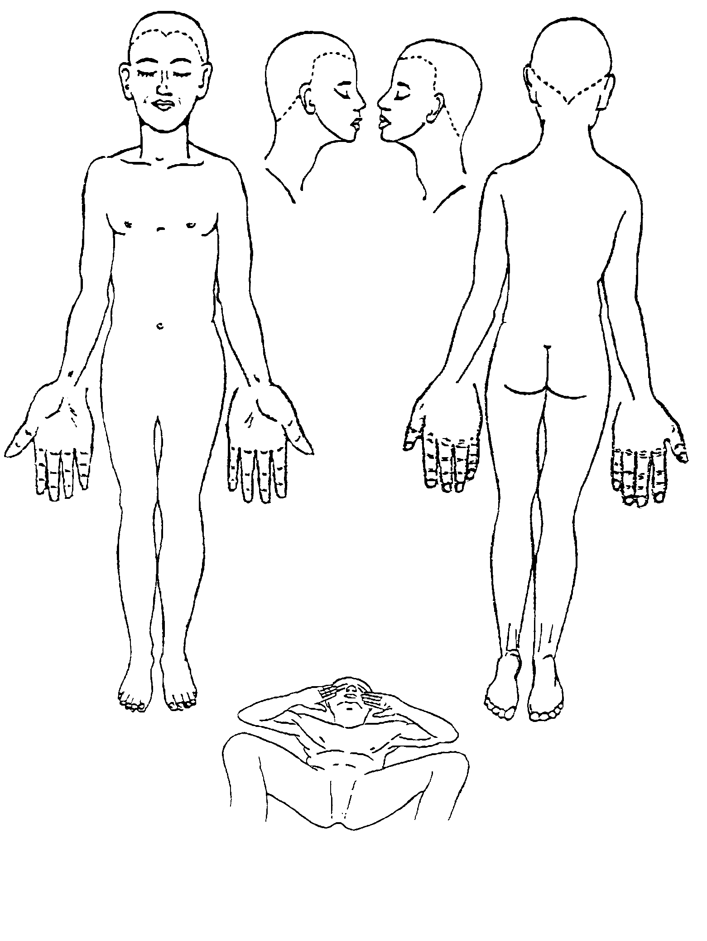

Farbschema

2°-A = blau*)

2°-B = blau-rot-gestreift

3° = rot*)

4° = schwarz*)

*) in Skizze eintragen